Project Report On
Candlestick Pattern Recognition
Submitted By:
Milroman Singh
Abhijeet Singh
Jashanpreet Singh
Jaspreet Singh
Under the Guidance of:
Sushrut Nagula



Centre for Development of Advanced Computing A-34, Industrial Area, Phase-VIII Sahibzada Ajit Singh Nagar (Mohali), Punjab – 160071

Department of Computer Science & Engineering
Centre for Development of Advanced Computing (C-DAC), Mohali
CANDIDATES' DECLARATION
We, Milroman Singh, Abhijeet Singh, Jashanpreet Singh, and Jaspreet Singh, hereby declare that we have undertaken this summer training project titled “Candlestick Pattern Recognition using Computer Vision and Machine Learning” at the Centre for Development of Advanced Computing (C-DAC), Mohali, under the guidance of Sushrut Nagula. The work presented in this training report is an authentic record of our own training work, carried out during the summer training period of 2026.

Signature of the Candidates

The summer training Viva–Voce Examination of _______________________________ has been held on ____________________ and accepted.

Signature of Examiner
Abstract
Manual identification of candlestick patterns from stock charts is time-consuming and prone to human error. This project presents a hybrid Computer Vision and Machine Learning system that automates candlestick pattern recognition from chart images. Historical OHLC (Open, High, Low, Close) data is used to generate a labeled dataset via rule-based technical-analysis definitions, rendered as chart images using the mplfinance library. An OpenCV-based pipeline consisting of grayscale conversion, adaptive thresholding, morphological cleaning, and contour detection isolates individual candlesticks from each image and measures their geometric properties directly from pixels.
These measurements are converted into scale-invariant ratio features and used to train and compare four classical machine learning classifiers — Support Vector Machine, Random Forest, Decision Tree, and K-Nearest Neighbors — across six candlestick patterns: Doji, Hammer, Shooting Star, Bullish Engulfing, Bearish Engulfing, and Spinning Top. Random Forest achieved the best performance with a 96.3% F1-score and was deployed in a Streamlit web application supporting both direct image upload and live stock-ticker input. Beyond pattern classification, the system also generates a graded trading recommendation — Strong Buy, Buy, Hold, Sell, or Strong Sell — by combining the predicted signal with the model's confidence score. The results confirm that classical, interpretable machine learning is sufficient for this well-structured problem, without requiring deep learning.
Acknowledgement
It is our proud privilege and duty to acknowledge the help and guidance received from several people in the preparation of this report. It would not have been possible to prepare this report in its present form without their valuable help, cooperation, and guidance.
First and foremost, we wish to record our sincere gratitude to our mentor, Sushrut Nagula, for his constant support, technical guidance, and encouragement throughout the duration of this training, and for making available the resources and facilities needed to complete this project.
We also wish to thank the Centre for Development of Advanced Computing (C-DAC), Mohali, for providing us with this opportunity and the environment to learn and apply Computer Vision and Machine Learning to a real-world problem.
Last but not the least, we wish to thank our families for their constant encouragement and support throughout our studies.
About the Institute
The Centre for Development of Advanced Computing (C-DAC) is a premier research and development organisation under the Ministry of Electronics and Information Technology (MeitY), Government of India, engaged in the design, development, and deployment of advanced Information Technology solutions. C-DAC's Mohali centre, located in Punjab, is known for its work in high-performance computing, cybersecurity, and professional IT training programs.
Through its summer training and skill-development programs, C-DAC provides students with hands-on, project-based exposure to contemporary technologies, including Python programming, computer vision, machine learning, and full-stack application development. This pedagogical approach combines theoretical grounding with practical implementation, enabling trainees to build complete, working systems rather than isolated exercises.
This training report is a product of one such program, in which the authors were guided through the design and implementation of a complete Computer Vision and Machine Learning application, from dataset generation through to a deployed, tested web application.
List of Figures
- Figure 1.1: Candlestick anatomy — body, upper wick, and lower wick relative to Open, High, Low, and Close.
- Figure 1.2: End-to-end system flowchart, showing both input modes converging into a shared pipeline.
- Figure 1.3: Module-level architecture, mapping the pipeline onto the project's folder structure.
- Figure 2.1: Preprocessing pipeline output — grayscale, thresholding, noise removal, and morphological cleaning applied to a generated Hammer sample.
- Figure 3.1: Bar chart of mean body-to-range ratio by pattern class, computed from extracted test-set features.
- Figure 3.2: Bar chart comparing F1-score across the four trained classification models.
List of Tables
- Table 1.1: Tools and their purpose.
- Table 1.2: Structure of a multi-class confusion matrix.
- Table 2.1: Hyperparameters used for each trained model.
- Table 3.1: Model performance metrics (accuracy, precision, recall, F1-score).
- Table 3.2: Mean feature ratios by pattern class.
Definitions, Acronyms and Abbreviations
Acronym | Full Form | Definition
OHLC | Open, High, Low, Close | The four price points that define one candlestick.
CV | Computer Vision | A field of AI concerned with extracting information from images.
ML | Machine Learning | A subset of AI focused on learning patterns from data.
SVM | Support Vector Machine | A supervised learning algorithm that finds a maximum-margin decision boundary.
KNN | K-Nearest Neighbors | A classifier that predicts based on the majority class among the nearest training samples.
CSV | Comma-Separated Values | A plain-text file format used for storing tabular data.
GUI | Graphical User Interface | The visual, interactive front-end through which a user operates the system.
TP | True Positive | A correctly predicted positive instance.
TN | True Negative | A correctly predicted negative instance.
FP | False Positive | An instance incorrectly predicted as positive.
FN | False Negative | An instance incorrectly predicted as negative.
F1 | F1-Score | The harmonic mean of precision and recall.
pkl | Pickle Format | A Python serialization format used to store trained model objects.
Contents
Candidates' Declaration ii
Abstract iii
Acknowledgement iv
About the Institute v
List of Figures vi
List of Tables vii
Definitions, Acronyms and Abbreviations viii
CHAPTER 1 INTRODUCTION 1
1.1 Background 1
1.2 Theoretical Explanations 1
1.3 System Architecture and Tools 6
1.4 Performance Evaluation Metrics 9
CHAPTER 2 TRAINING WORK UNDERTAKEN 12
2.1 Dataset 12
2.2 Data Preprocessing 13
2.3 Model Training 15
2.4 Saving Artifacts 16
2.5 Deployment and Web UI 16
CHAPTER 3 RESULTS AND DISCUSSION 18
3.1 Model Performance Metrics 18
3.2 Discussion and Conclusion 21
CHAPTER 4 CONCLUSION AND FUTURE SCOPE 22
4.1 Conclusion 22
4.2 Future Scope 22
REFERENCES 23
APPENDIX 24
CHAPTER 1 INTRODUCTION
1.1 Background
Candlestick charts are one of the most widely used tools in technical analysis of financial markets. Each candlestick visually encodes four price points for a given trading period — open, high, low, and close — and specific arrangements of one or more candlesticks form recognizable “patterns” that traders interpret as signals of likely future price movement.
While experienced traders can often identify these patterns by eye, manually scanning charts is slow, subjective, and error-prone, particularly for traders who are still developing pattern-recognition intuition, or when many tickers must be monitored simultaneously. This project addresses that problem by developing a system that automates candlestick pattern recognition end-to-end, from a chart image or a stock ticker symbol, using computer vision for detection and classical machine learning for classification.
1.2 Theoretical Explanations
1.2.1 Candlestick Chart Fundamentals
A single candlestick is defined by four values — Open, High, Low, and Close — for a fixed time interval. The body of the candle spans the distance between the open and close prices, while the upper and lower wicks (also called shadows) extend to the high and low respectively. Figure 1.1 illustrates this anatomy.
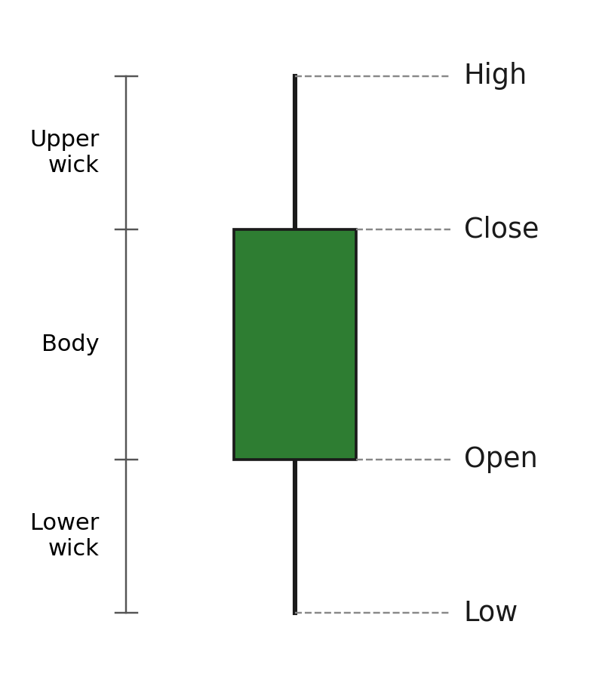
Figure 1.1: Candlestick anatomy — body, upper wick, and lower wick relative to Open, High, Low, and Close.
These geometric quantities are computed as shown in Equation 1.1.
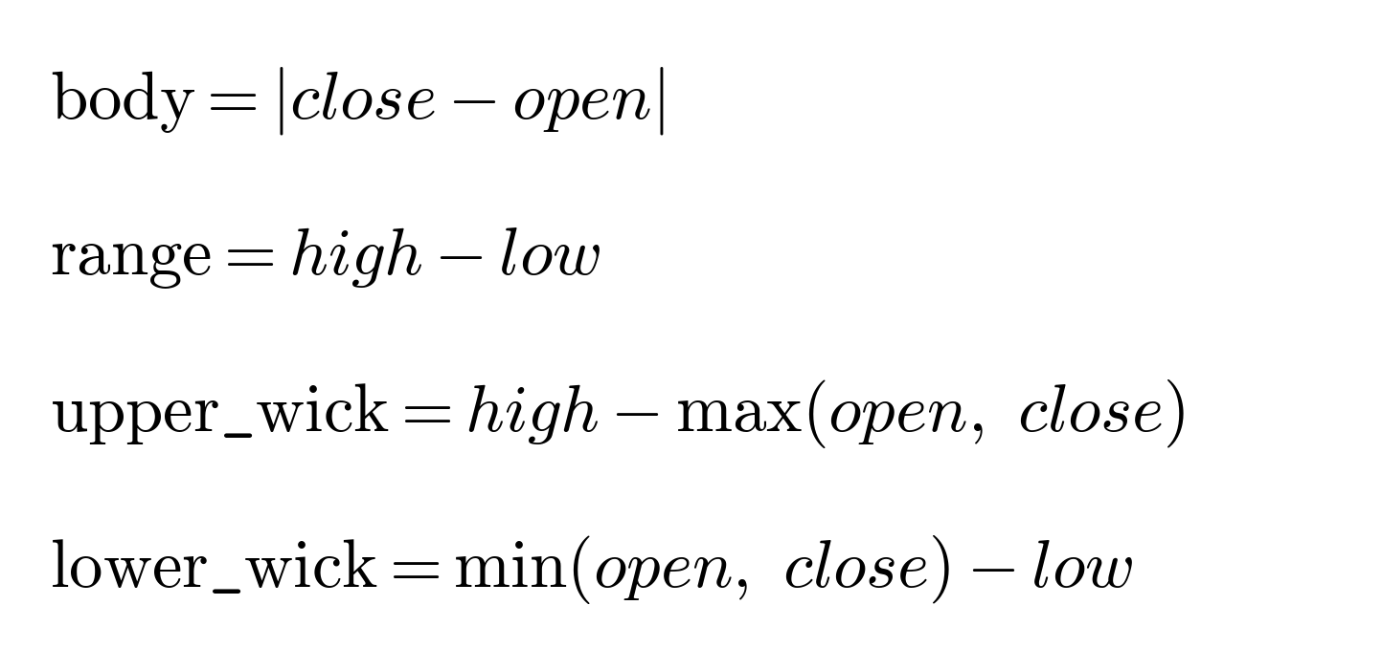
Equation 1.1: Candlestick geometric quantities.
1.2.2 Pattern Definitions
Each of the six target patterns is defined as a precise relationship between body and wick proportions, rather than a subjective visual judgement. For example, a Doji — a candle where the market essentially closed where it opened — is defined by Equation 1.2.
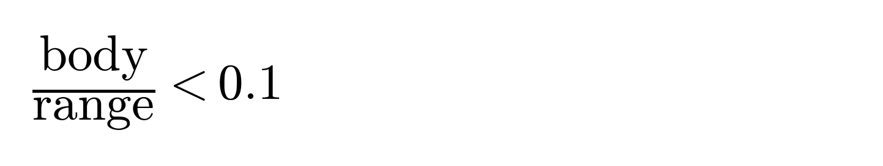
Equation 1.2: Doji condition.
A Hammer — a small body sitting near the top of the candle's range, with a long lower wick and a negligible upper wick — is defined by Equation 1.3. A Shooting Star is the vertical mirror of this condition, with the roles of the upper and lower wick reversed.
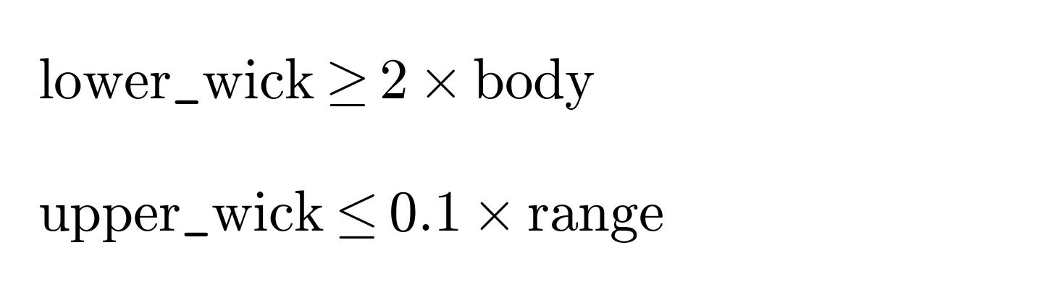
Equation 1.3: Hammer condition (Shooting Star is the upper/lower-wick mirror of this rule).
Spinning Top requires a moderate body with roughly balanced upper and lower wicks, while Bullish and Bearish Engulfing are defined not by ratios within a single candle, but by a containment relationship between two consecutive candles' bodies, combined with a reversal in direction.
1.2.3 Feature Engineering Formulation
Absolute pixel measurements are not directly useful for classification, since a large candle and a small candle can represent the same pattern. To make the features scale-invariant, each geometric quantity is expressed as a ratio of the candle's total range, as shown in Equation 1.4.
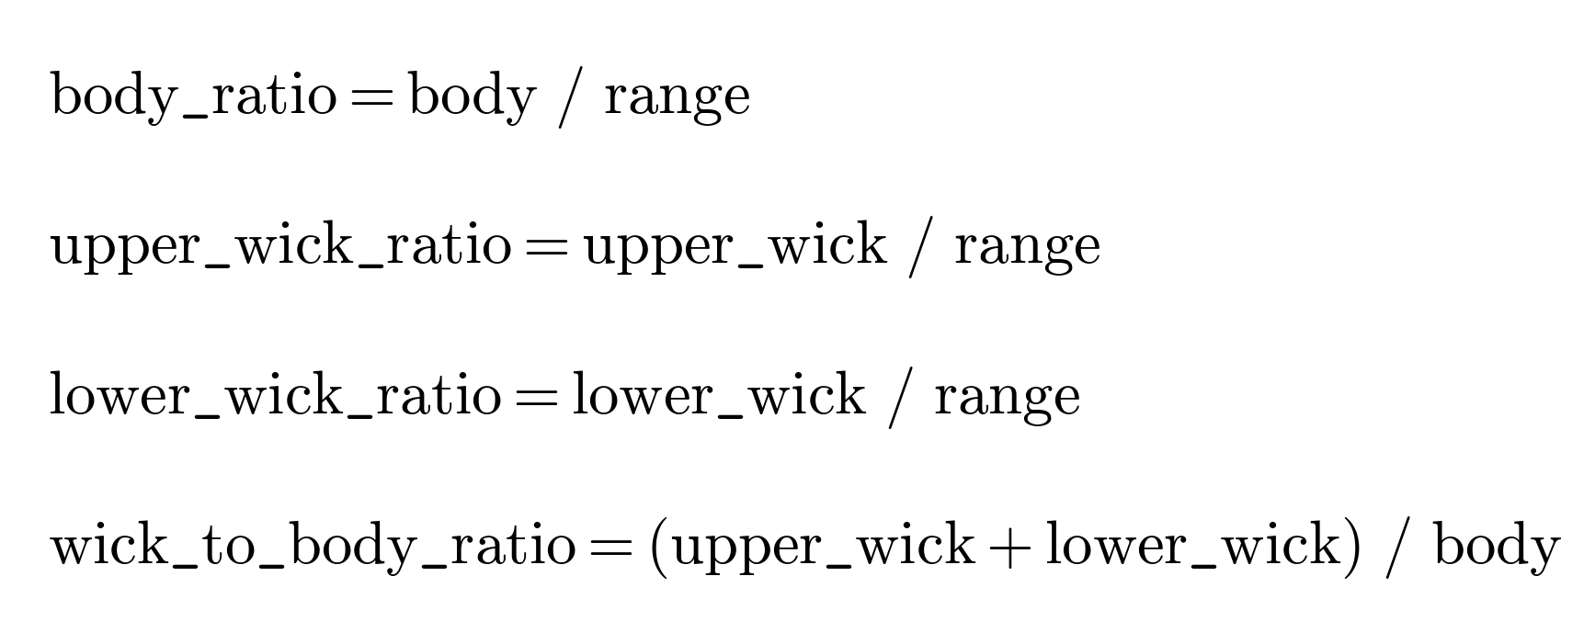
Equation 1.4: Scale-invariant ratio features computed for classification.
These four ratios, together with a bullish/bearish color flag, are computed for the last two candles in every image, producing a fixed-length, eleven-column feature vector regardless of whether the target pattern involves one candle or two.
1.2.4 Decision Tree and Random Forest Classification
A Decision Tree classifies data by recursively splitting the feature space on the value of a single feature at each node, choosing the split that most reduces class impurity. The most common impurity measure, Gini impurity, is defined in Equation 1.5, where C is the number of classes and p_i is the proportion of samples belonging to class i at that node.
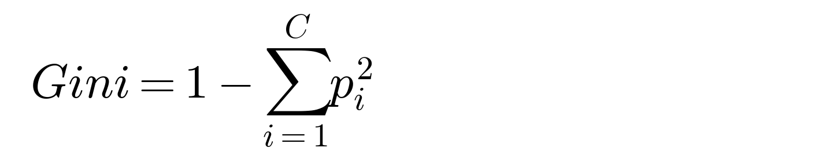
Equation 1.5: Gini impurity.
A Random Forest is an ensemble of many such decision trees, each trained on a random bootstrap sample of the training data and a random subset of features at each split. The final prediction is obtained by aggregating the individual trees' predictions, typically by majority vote for classification, as shown in Equation 1.6.
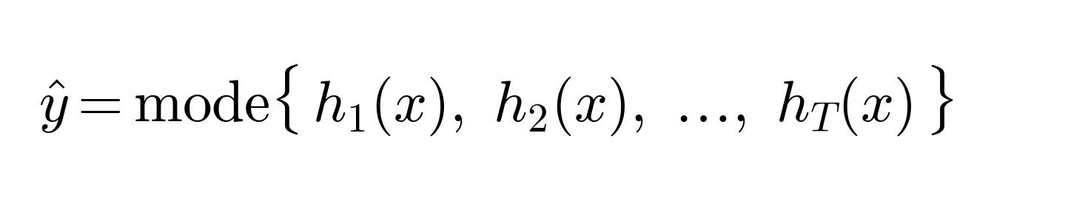
Equation 1.6: Random Forest ensemble prediction, where h_t(x) is the prediction of the t-th tree and T is the total number of trees.
Because this project's features were themselves engineered from threshold-based rules (Equations 1.2 and 1.3), tree-based models are a natural fit: a decision tree learns exactly this kind of “if feature exceeds threshold” logic directly from data, which motivated their inclusion as primary candidates alongside Support Vector Machine and K-Nearest Neighbors classifiers.
1.2.5 Related Work
Existing research on candlestick pattern recognition has largely converged on deep learning approaches applied to image-like encodings of price data. One prominent method encodes OHLC time series into images using the Gramian Angular Field technique, then trains a convolutional neural network to learn candlestick patterns from these encoded images [1]. Other work has extended into direct image-based object detection: a fine-tuned YOLOv8 model has been used to identify candlestick chart patterns in real time, trained on a dataset of roughly 9,000 chart images and reaching approximately 93% training accuracy [2]. Tsai et al. similarly proposed an extended CNN-based approach specifically for automated candlestick pattern recognition [3], reflecting a broader trend of applying deep computer-vision techniques to this domain.
However, deep learning is not universally necessary for this task. Ananthi and Vijayakumar evaluated MLP, CNN, AdaBoost, Random Forest, and XGBoost on GAF-encoded candlestick images and found that traditional machine learning models could match or exceed deep learning performance, concluding that complex CNN architectures are not strictly required for satisfactory candlestick classification accuracy [4]. This finding directly supports the design choice made in this project: rather than encoding whole images for a CNN, interpretable geometric features are extracted and used with classical machine learning. It is also worth noting that much of the existing literature on candlestick pattern recognition remains limited to a relatively small number of patterns [5], rather than the full traditional taxonomy of dozens of named patterns — this project follows the same deliberately narrow-but-deep approach, targeting six well-defined patterns.
1.3 System Architecture and Tools
The following diagrams illustrate the high-level architecture of the candlestick pattern recognition system, detailing the flow from data input to final prediction, and how this flow maps onto the project's code organization.
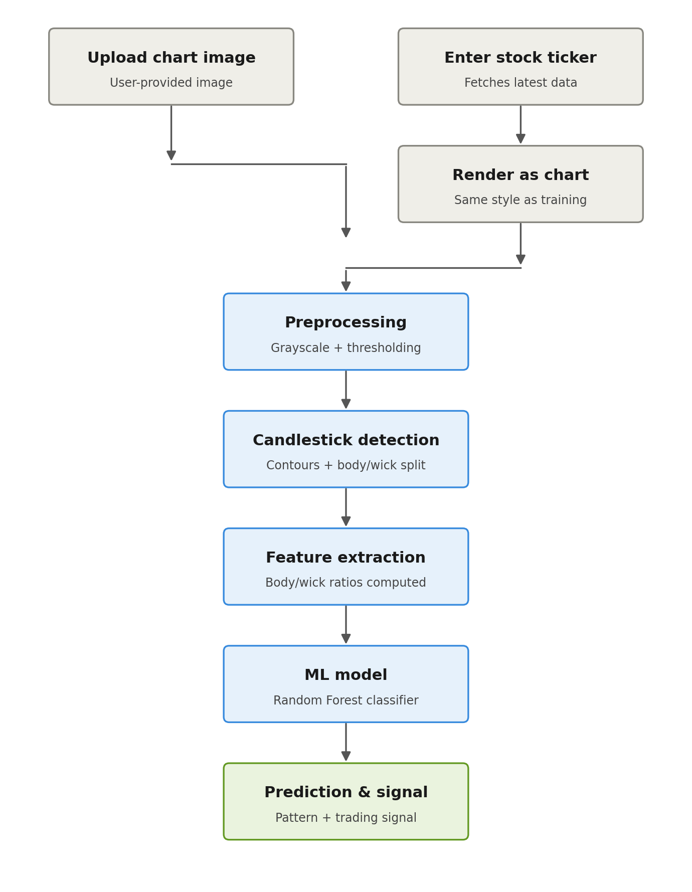
Figure 1.2: End-to-end system flowchart, showing both input modes converging into a shared pipeline.
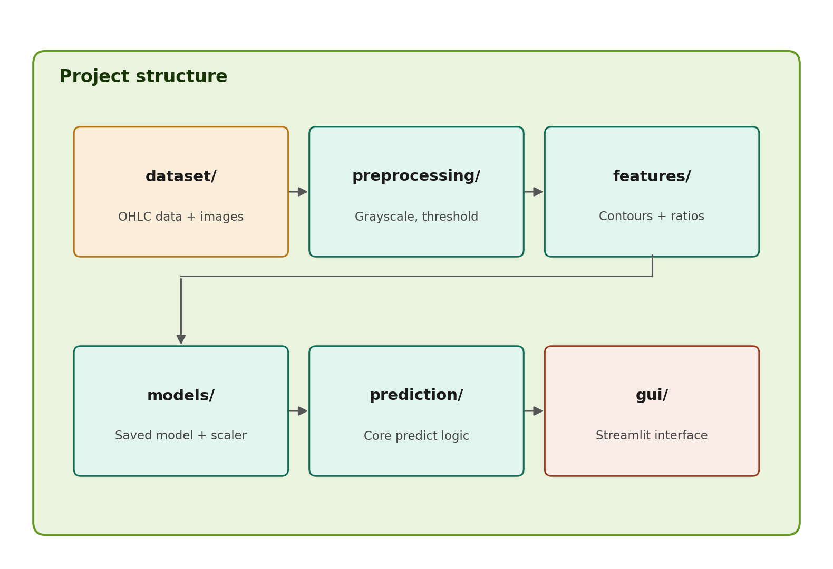
Figure 1.3: Module-level architecture, mapping the pipeline onto the project's folder structure.
Table 1.1: Tools and their purpose.
Tool | Purpose
Python | Core programming language for the entire application.
OpenCV | Image preprocessing and candlestick detection.
yfinance | Historical and latest-available stock market data retrieval.
mplfinance / Matplotlib | Candlestick chart rendering and visualization.
scikit-learn | Model training (SVM, Random Forest, Decision Tree, KNN) and evaluation.
pandas / NumPy | Numerical and tabular data handling.
joblib | Model and scaler persistence.
Streamlit | Web-based graphical user interface.
pytest | Automated testing framework.

1.4 Performance Evaluation Metrics
Evaluating a multi-class classifier requires more than a single accuracy number. This project uses a confusion matrix together with macro-averaged precision, recall, and F1-score, so that performance on every one of the six pattern classes is weighted equally rather than dominated by the most common class.
1.4.1 Confusion Matrix
For each class, predictions fall into one of four categories relative to the ground truth, summarized in Table 1.2.
Table 1.2: Structure of a multi-class confusion matrix (per class, one-vs-rest view).
 | Actual Positive | Actual Negative
Predicted Positive | True Positive (TP): correctly predicted as this class. | False Positive (FP): incorrectly predicted as this class.
Predicted Negative | False Negative (FN): actually this class, predicted as another. | True Negative (TN): correctly predicted as not this class.

1.4.2 Accuracy
Accuracy is the proportion of all predictions that were correct, as shown in Equation 1.7.
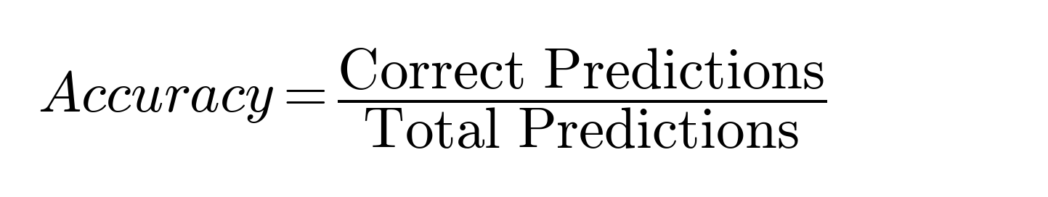
Equation 1.7: Accuracy.
1.4.3 Precision and Recall
Precision measures, of everything predicted as a given class, how much actually belonged to that class. Recall measures, of everything that actually belonged to a class, how much was correctly identified. For a six-class problem, these are macro-averaged — computed per class and then averaged equally — as shown in Equations 1.8 and 1.9.
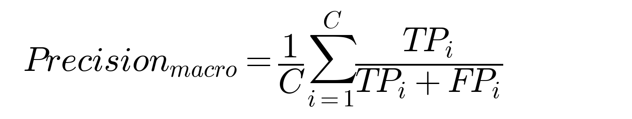
Equation 1.8: Macro-averaged precision.
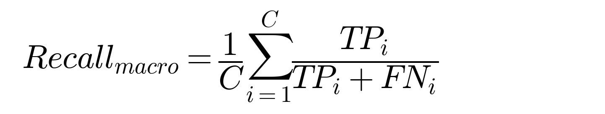
Equation 1.9: Macro-averaged recall.
1.4.4 F1-Score
Precision and recall individually provide useful but incomplete pictures of performance. The F1-score, the harmonic mean of the two, offers a single balanced measure, as shown in Equation 1.10.
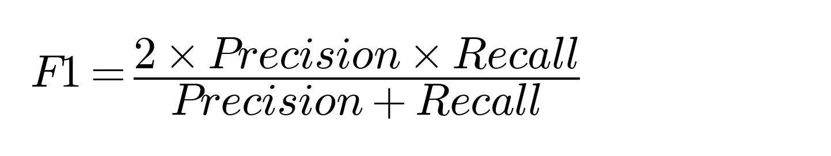
Equation 1.10: F1-score.
CHAPTER 2 TRAINING WORK UNDERTAKEN
2.1 Dataset
Unlike many supervised learning tasks, no public, pre-labeled dataset of candlestick pattern images matching this project's exact six-class scope was available. Instead, a labeled dataset was generated directly from real historical price data, using the same mathematical pattern definitions established in Section 1.2.2 to assign labels.
Historical daily OHLC data was downloaded using the yfinance library for thirteen tickers spanning both the NSE (Indian) and US markets, providing a diverse mix of price behaviour. For each ticker's price history, every candle was checked against the rule-based definitions of all six target patterns; matching six-candle windows (five candles of context plus the pattern candle, or two pattern candles for the Engulfing patterns) were rendered as chart images using mplfinance, in a fixed visual style consistent with what a user's uploaded chart or ticker-fetched chart would later look like.
Because some patterns (particularly Doji and Spinning Top) occur far more frequently in real price data than others (such as Shooting Star), the matched candidates were randomly sampled down to approximately 200 images per class, yielding a final balanced dataset of 1,200 labeled images across the six classes.
2.2 Data Preprocessing
2.2.1 Image Preprocessing
Each chart image, whether from the generated dataset or a live prediction request, passes through a fixed preprocessing pipeline before detection. The image is first converted to grayscale, then binarized using inverse binary thresholding (candle pixels, which are darker than the white background, become the foreground), then cleaned using median-blur noise removal and morphological closing to repair any small gaps in thin wick lines. Figure 2.1 shows this pipeline applied to an actual generated sample.

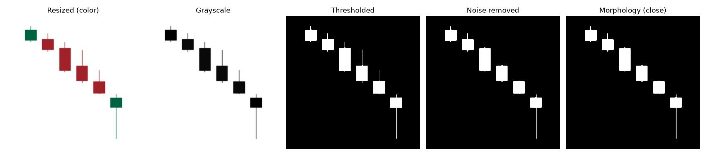
Figure 2.1: Preprocessing pipeline output — grayscale, thresholding, noise removal, and morphological cleaning applied to a generated Hammer sample.
2.2.2 Candlestick Detection
Contour detection is applied to the cleaned binary mask to isolate each candle as a separate connected region. The detected contours are sorted left to right by their horizontal position, so that the last contour in the list always corresponds to the most recent candle in the window. Within each candle's bounding box, a row-by-row scan measures the horizontal pixel width at every row; rows wider than a threshold fraction of the maximum width are classified as the candle's body, and the remaining rows are classified as wick. This distinguishes the body rectangle from the thin wick line using only geometry, without needing color information. Color analysis on the original (non-grayscale) image, restricted to the detected body region, then determines whether the candle is bullish or bearish.
2.2.3 Feature Extraction
For the last two detected candles in an image, the pixel-based body and wick measurements are converted into the four ratio features defined in Equation 1.4, plus a bullish/bearish flag for each candle. This produces a fixed-length, eleven-column feature vector for every image, regardless of whether the labeled pattern is a single-candle pattern (in which case the preceding candle's features act as additional context) or a two-candle Engulfing pattern.
2.3 Model Training
The extracted feature dataset (1,200 rows, eleven feature columns plus a class label) was split into training and test sets using an 80/20 ratio. The split was stratified on the class label, ensuring that all six pattern classes remained proportionally represented in both subsets, and a fixed random seed was used throughout for reproducibility. Feature values were standardized using a StandardScaler fitted only on the training data, then applied to both the training and test sets, to avoid leaking test-set statistics into preprocessing.
Four classical machine learning classifiers were trained and compared. Table 2.1 summarizes the key hyperparameters used for each.
Table 2.1: Hyperparameters used for each trained model.
Model | Key hyperparameters
Support Vector Machine | kernel = 'rbf', C = 1.0
Random Forest | n_estimators = 100
Decision Tree | max_depth = 8
K-Nearest Neighbors | n_neighbors = 5

Each model was trained on the identical standardized training set and evaluated on the same held-out test set, ensuring a fair, controlled comparison. The complete training and evaluation code is provided in Appendix A.
2.4 Saving Artifacts
To allow the trained model to be reused for prediction without retraining, the best-performing model and its associated feature scaler were serialized to disk using joblib. Two artifacts were saved:
- RandomForest.pkl — the trained Random Forest classifier object, including its learned tree structures.
- scaler.pkl — the fitted StandardScaler, ensuring that any new feature vector at prediction time is scaled using the exact same mean and variance statistics computed during training.
Saving both artifacts together, rather than the model alone, is essential: applying a different or unfitted scaler at prediction time would silently produce incorrect predictions, since the model's learned weights are only meaningful relative to the specific scaling used during training.
2.5 Deployment and Web UI
To make the system accessible to an end user, a web application was developed using Streamlit, an open-source Python framework for building interactive data applications. The application exposes two input modes through a single shared prediction pipeline:
- Upload Chart Image — the user uploads a chart image directly, which is passed straight into the detection pipeline.
- Enter Stock Ticker — the user enters a ticker symbol; the application fetches the latest available OHLC data, renders it in the same visual style as the training data, and passes the rendered image through the identical detection pipeline used for uploaded images.
Both paths converge on the same underlying prediction function, ensuring identical, consistent behaviour regardless of input method. The predicted pattern is mapped to a Bullish, Bearish, or Neutral trading signal. This signal is further combined with the model's own confidence score (the maximum predicted class probability) to produce a graded recommendation — Strong Buy or Buy for a Bullish signal, Strong Sell or Sell for a Bearish signal, and Hold for a Neutral signal — with the “Strong” qualifier applied only when the model's confidence exceeds a configurable threshold. The interface displays the input chart, the detected pattern, the signal, the recommendation, and the underlying confidence score.
CHAPTER 3 RESULTS AND DISCUSSION
This project had two primary objectives: first, to train and compare classical machine learning classifiers capable of accurately distinguishing between six candlestick patterns from image-derived features, and second, to deploy the best-performing model into a usable web application supporting both image and ticker-based input. Both objectives were met. This chapter details the performance of the trained classifiers and discusses the resulting model's behaviour.
3.1 Model Performance Metrics
3.1.1 Accuracy and Comparative Scores
All four models were evaluated on the same held-out test set (240 samples, stratified across all six classes). Table 3.1 summarizes accuracy, precision, recall, and F1-score for each model, and Figure 3.2 visualizes the F1-score comparison.
Table 3.1: Model performance metrics (accuracy, precision, recall, F1-score).
Model | Accuracy | Precision | Recall | F1-Score
Random Forest (final) | 0.963 | 0.964 | 0.962 | 0.963
Decision Tree | 0.921 | 0.925 | 0.921 | 0.921
SVM | 0.908 | 0.910 | 0.908 | 0.908
KNN | 0.892 | 0.892 | 0.892 | 0.890

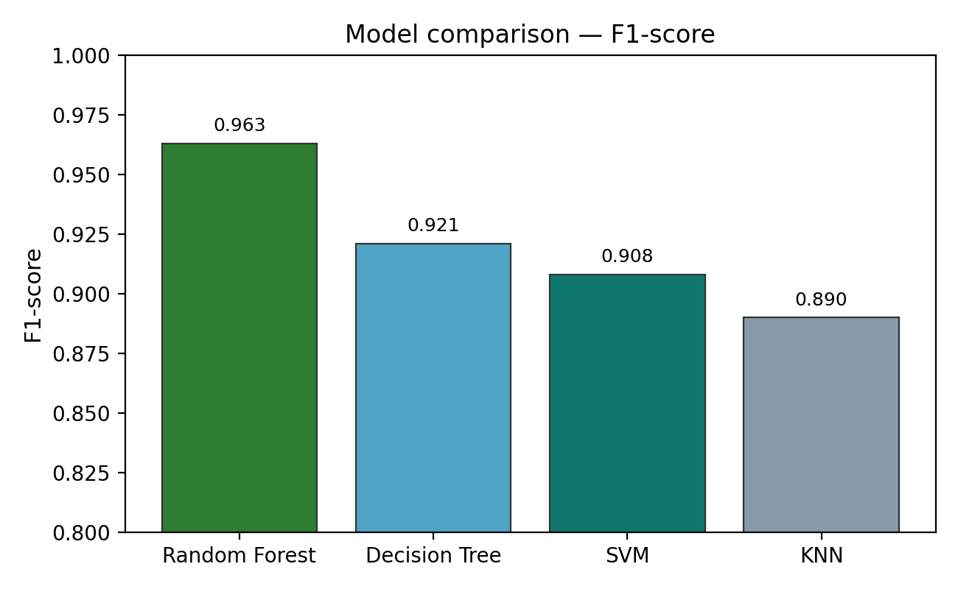
Figure 3.2: Bar chart comparing F1-score across the four trained classification models.
Tree-based models (Random Forest and Decision Tree) outperformed the distance- and margin-based models (KNN and SVM). This is consistent with the fact that the underlying features were themselves engineered from threshold-based rules (Section 1.2.4): a decision boundary of the form “feature exceeds threshold” is exactly what a tree learns natively, whereas SVM and KNN have no such structural advantage on this feature set. Random Forest improved further on a single Decision Tree by averaging across many trees, which smooths out the effect of measurement noise on any individual training example.
3.1.2 Class-wise Feature Validation
As a sanity check independent of any trained model, the mean value of the body_ratio feature was computed per class directly from the extracted test-set features. Figure 3.1 and Table 3.2 show that this purely geometric quantity, computed from detected pixels rather than exact price data, already separates the classes in the expected direction: Doji has the smallest mean body ratio, Spinning Top and the two Hammer-family patterns sit in the low-to-moderate range, and both Engulfing patterns — whose defining trait is a large, dominant body — have the highest mean body ratio.
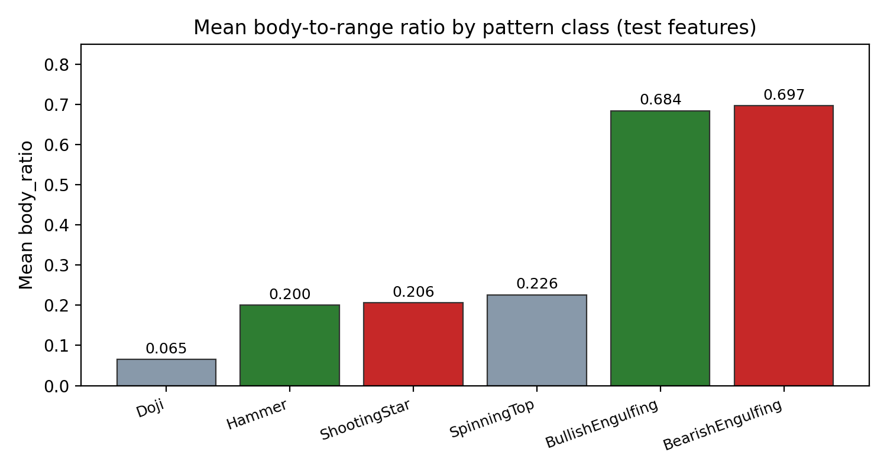
Figure 3.1: Bar chart of mean body-to-range ratio by pattern class, computed from extracted test-set features.
Table 3.2: Mean feature ratios by pattern class.
Pattern | body_ratio | upper_wick_ratio | lower_wick_ratio
Doji | 0.065 | 0.429 | 0.506
Hammer | 0.200 | 0.039 | 0.762
Shooting Star | 0.206 | 0.758 | 0.036
Spinning Top | 0.226 | 0.386 | 0.388
Bullish Engulfing | 0.684 | 0.162 | 0.154
Bearish Engulfing | 0.697 | 0.130 | 0.174

Notably, Hammer and Shooting Star have nearly identical body ratios (0.200 vs. 0.206) but almost perfectly mirrored wick ratios, confirming that these two patterns are geometric reflections of one another and that the wick-ratio features, not the body ratio alone, are what the classifier relies on to distinguish them.
3.1.3 Confusion Analysis
Across all four models, Doji was consistently the most-confused class, with its errors concentrated against Spinning Top. This is explainable directly from Table 3.2: Doji's defining rule requires body_ratio below 0.1, while Spinning Top's range begins at 0.1 — a boundary narrow enough that small pixel-measurement noise in the detection step can occasionally push a genuine Doji's measured ratio just across this threshold. Random Forest was the most robust to this boundary noise, since averaging across many trees reduces the influence of any single borderline measurement.
3.1.4 Testing Summary
A pytest-based automated test suite was developed covering four areas: unit tests verifying the rule-based pattern-labeling functions against known geometric cases; consistency checks confirming that detected body and wick measurements always sum to the full candle range; edge-case handling for missing files, corrupted files, and images with no detectable candles; and a performance test confirming prediction latency remains under two seconds. All fifteen tests passed, confirming that the pipeline fails safely and predictably on invalid input rather than producing silent incorrect results.
3.2 Discussion and Conclusion
The collective results demonstrate that a classical, interpretable machine learning approach is both effective and appropriate for this problem. The high test-set accuracy (96.3%) and F1-score (0.963) of the final Random Forest model provide strong confidence in its predictive power, while the class-wise feature analysis (Section 3.1.2) confirms that this performance is grounded in genuinely meaningful, explainable geometric features rather than an opaque, unverifiable decision process.
A real-world test conducted during development also surfaced an important limitation: the system's fixed-polarity thresholding assumes a light chart background, and does not currently handle dark-themed chart screenshots correctly. This is discussed further, along with other known limitations, in Chapter 4.
CHAPTER 4 CONCLUSION AND FUTURE SCOPE
4.1 Conclusion
This project successfully automates candlestick pattern recognition end-to-end: from raw historical price data, through image rendering, computer vision-based detection, feature engineering, and machine learning classification, to a usable web application. All planned objectives were achieved. The Random Forest classifier achieved strong, well-balanced performance across all six target patterns, and feature-level validation confirmed that the extracted geometric ratios faithfully reproduce the same relationships used to mathematically define each pattern — demonstrating that the complete pipeline, not just the final model, behaves correctly and explainably. The addition of a graded Buy/Sell recommendation, combined with the system's documented and honestly-stated limitations, makes this project a practical, defensible demonstration of applying computer vision and classical machine learning to a real financial-domain problem.
4.2 Future Scope
- Adaptive background-brightness detection to support both light- and dark-themed chart images.
- Incorporating preceding price-trend context before classifying reversal patterns such as Hammer or Shooting Star.
- Group-based (per-ticker) train/test splitting to fully eliminate near-duplicate leakage between overlapping candle windows.
- Expanding the pattern set to multi-candle formations such as Three White Soldiers and Morning/Evening Star.
- Benchmarking against a CNN-based deep learning approach to quantify the accuracy/interpretability trade-off.
- Building a hand-labeled real-screenshot validation dataset to rigorously measure real-world accuracy.
REFERENCES
[1] “Recognition of candlestick patterns using deep learning,” Financial Innovation (Journal of Finance and Data Science), 2022.
[2] “Candlestick chart pattern recognition using a fine-tuned YOLOv8 model,” Medium, 2024.
[3] Y.-C. Tsai, S.-J. Wang, and J.-H. Chiang, “Explainable deep convolutional candlestick learner,” arXiv preprint arXiv:2001.02767, 2020.
[4] S. Ananthi and K. Vijayakumar, “Image-based candlestick pattern classification with machine learning,” in Proc. ACM Conf., 2023.
[5] “A novel candlestick pattern recognition model based on machine learning methods,” PRML Journal, 2022.
[6] “OpenCV: Open Source Computer Vision Library,” opencv.org, 2024. [Online]. Available: https://docs.opencv.org/
[7] Scikit-learn Developers, “scikit-learn: Machine Learning in Python,” scikit-learn.org, 2024. [Online]. Available: https://scikit-learn.org/stable/
[8] Streamlit Inc., “Streamlit documentation,” streamlit.io, 2024. [Online]. Available: https://docs.streamlit.io/
APPENDIX SOURCE CODE SNIPPETS
A.1 Candle Geometry and Pattern Rules
def candle_metrics(open_, high, low, close):
body = abs(close - open_)
rng = high - low
upper_wick = high - max(open_, close)
lower_wick = min(open_, close) - low
return body, rng, upper_wick, lower_wick
def is_doji(open_, high, low, close):
body, rng, _, _ = candle_metrics(open_, high, low, close)
return rng > 0 and (body / rng) < 0.1
A.2 Body/Wick Detection from Pixels
def classify_body_rows(binary_img, box):
x, y, w, h = box
crop = binary_img[y:y + h, x:x + w]
row_widths = []
for row in crop:
white_pixels = np.where(row > 0)[0]
if len(white_pixels) == 0:
row_widths.append(0)
else:
row_widths.append(white_pixels[-1] - white_pixels[0] + 1)
max_width = max(row_widths) if row_widths else 0
threshold = max_width * BODY_WIDTH_RATIO
body_rows = [i for i, rw in enumerate(row_widths) if rw >= threshold]
return y + min(body_rows), y + max(body_rows)
A.3 Feature Extraction
def compute_ratio_features(candle):
total_range = candle['total_range_px']
body = candle['body_height_px']
upper_wick = candle['upper_wick_px']
lower_wick = candle['lower_wick_px']
return {
'body_ratio': body / total_range if total_range > 0 else 0,
'upper_wick_ratio': upper_wick / total_range if total_range > 0 else 0,
'lower_wick_ratio': lower_wick / total_range if total_range > 0 else 0,
'wick_to_body_ratio': (upper_wick + lower_wick) / body if body > 0 else 0,
'is_bullish': 1 if candle['is_bullish'] else 0,
}
A.4 Model Definitions
def get_models():
return {
'SVM': SVC(kernel='rbf', C=1.0, random_state=42),
'RandomForest': RandomForestClassifier(n_estimators=100, random_state=42),
'DecisionTree': DecisionTreeClassifier(max_depth=8, random_state=42),
'KNN': KNeighborsClassifier(n_neighbors=5),
}
A.5 Recommendation Logic
def get_recommendation(signal, confidence, strong_threshold=0.75):
if signal == 'Bullish':
return 'Strong Buy' if confidence >= strong_threshold else 'Buy'
elif signal == 'Bearish':
return 'Strong Sell' if confidence >= strong_threshold else 'Sell'
else:
return 'Hold'

